**Fancy Media**

**Background**  
Why is the project being undertaken? This project is being undertaken because everyone uses social media. It would be interesting to see how close I can get to other simple social media sites, all while having a simple UI.

Who is the project for? The project is for people who like using simple social media sites.

Describe an opportunity or problem that the project is to address. A problem the project is to address is not having a complex UI.

**Benefits**

What benefits will this project provide to the target audience? It will allow them to view posts from others. It also has a dark theme so its easy on the eyes.

Explain how your app will improve the lives of your users. It is a simple media site to visit with easy-to-use menus.

**Key Features**

What are the key features/functionality that your app will provide to users?

* Users will be able to login with saved accounts.
* Users will be able to register new accounts.
* Users will be able to search through the list of groups.
* Users will be able to search through the list of users.
* Users will be able to search through a list of random posts made by users.

**Similar Applications**

**Reddit**

**Facebook**

**Color Palette**

Example below created with <https://material.io/resources/color/>

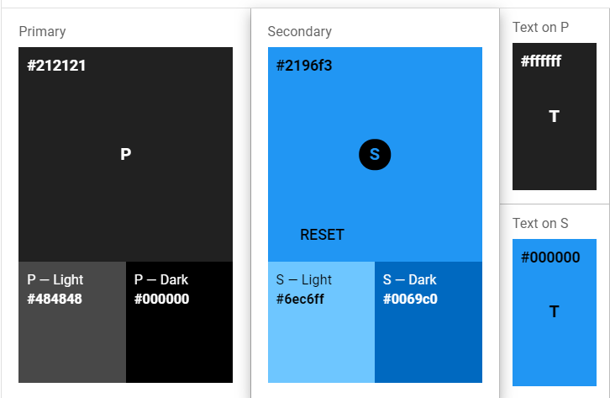

**UI Design Inspiration**

Include at least one image for design inspiration. Check here for ideas <https://www.pinterest.com/search/pins/?q=ui%20design>

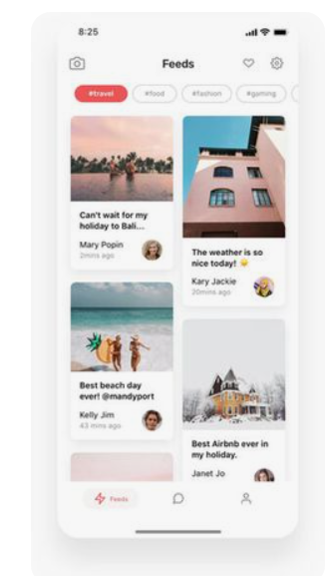

**Keep the section above to 1-3 pages!!**

***Insert feature documentation below, add sections as needed***

**Feature – Login Page**

Home Screen

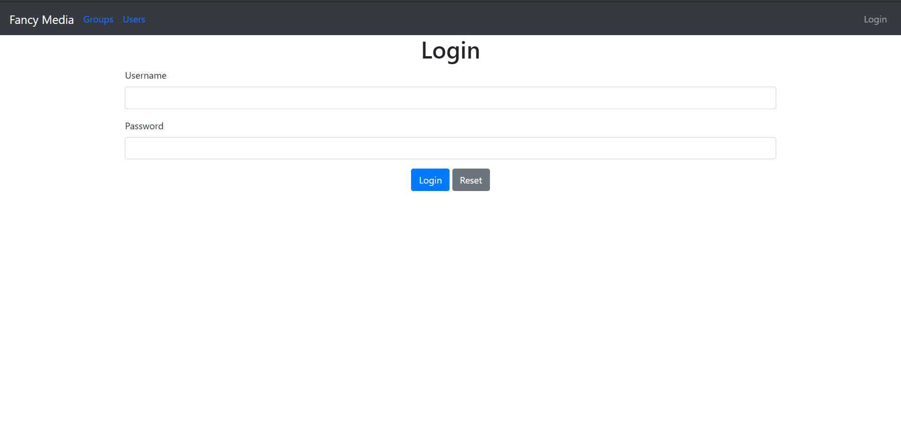

**Purpose and Background**

What will this feature allow users to do? This feature will allow users to login in with a saved account.

Why do they need this functionality? This functionality is needed to allow the user to view the groups and users.

Why is this feature important to the project? This feature is important because without it the user cannot use the website.

Explain the purpose and background of the feature. The purpose of this feature is to allow the user to view groups and other users.

**Workflow**

How will the user interact with the UI? The user will enter a username and password

What is the user workflow?

Provide step by step instructions.

**Possible Errors & Edge Cases**

What are the possible edge cases?

Consider errors that may arise from user error, software glitches, hardware glitches, and networking problems. Entering an invalid username or password should cause an error to show.

**Error Handling**

How will the user be notified of errors/exceptions? An error should show up under the field if there is an error.

How will the software handle the errors? Send ajax and json through the handlebars.

**Feature – User Management**

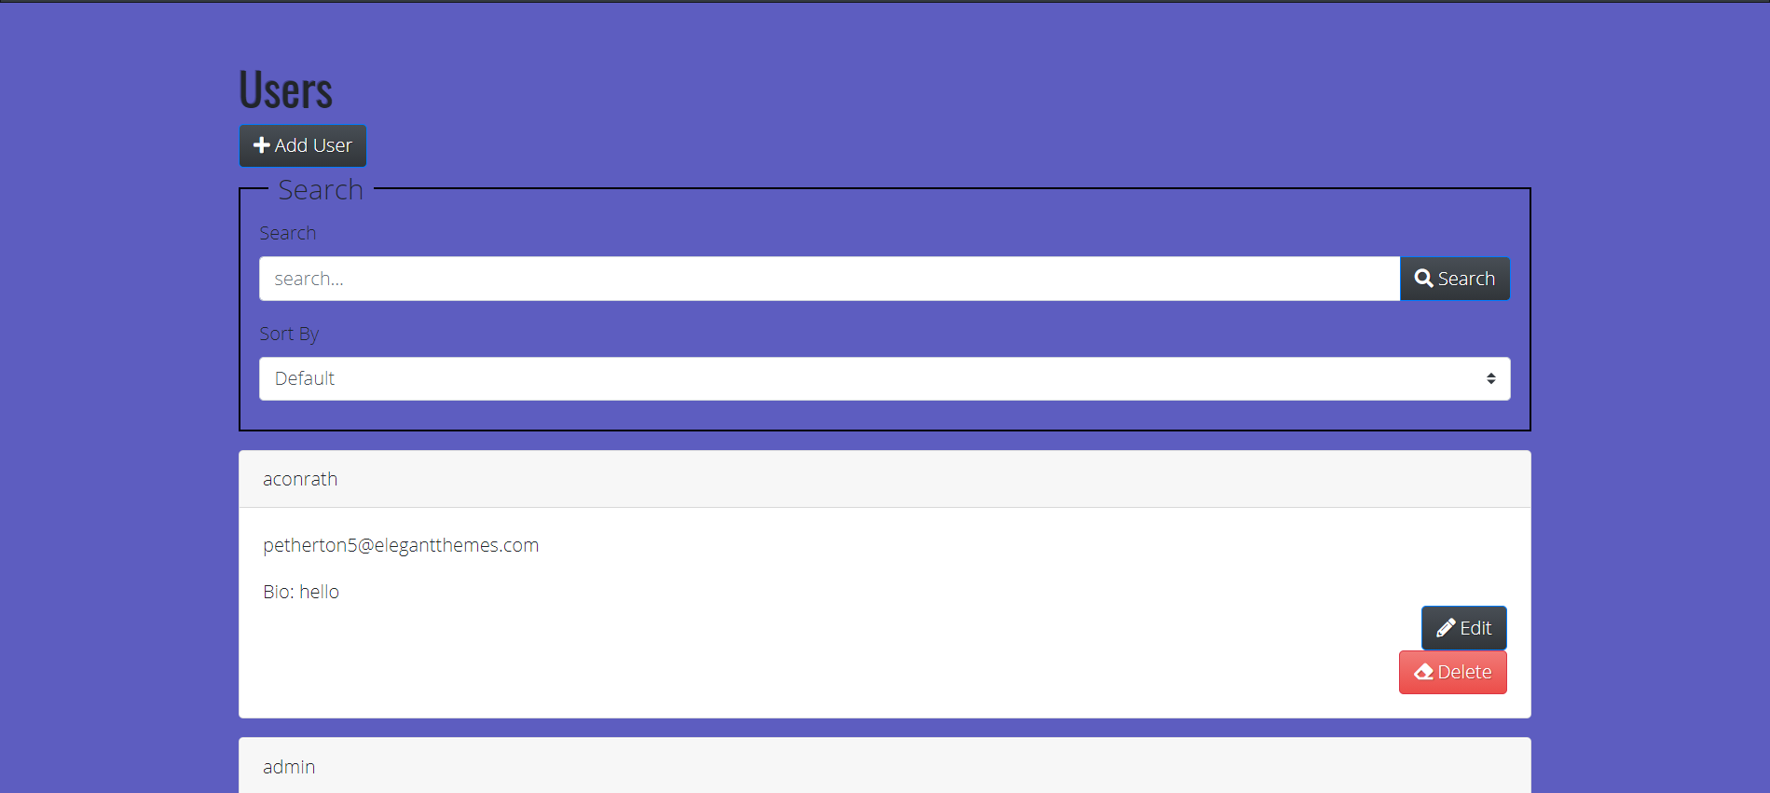

**Purpose and Background**

What will this feature allow users to do? This feature will allow users to search for individuals or sort the list by special classes.

Why do they need this functionality? They need this feature because it helps the user easily find someone.

Why is this feature important to the project? This feature is important because it is very valuable for easily moving around the page.

**Workflow**

How will the user interact with the UI? The user can enter a name and if it is found the page will display it, or the user can sort the page by specific classes.

What is the user workflow?

Provide step by step instructions.

**Possible Errors & Edge Cases**

What are the possible edge cases?

What could cause an error/exception? An error could occur if an invalid user is entered.

**Error Handling**

How will the user be notified of errors/exceptions If there is an error, the page should show that there is no user found.

How will the software handle the errors? Sending ajax and json to the handlebars.

**Feature – Group Management**

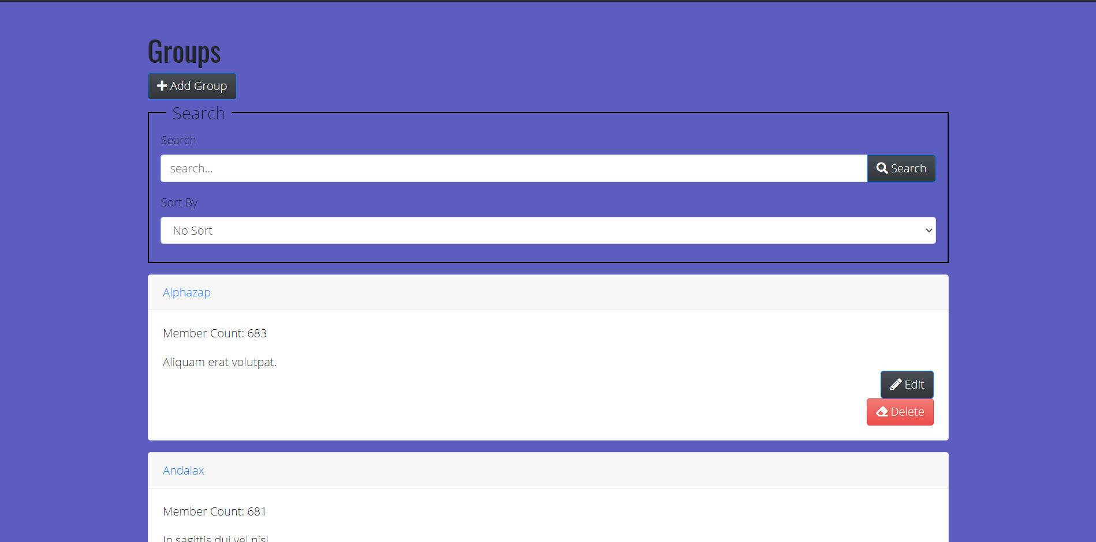

**Purpose and Background**

What will this feature allow users to do? This feature allows the user to search through the list of groups and view the details of the group.

Why do they need this functionality? They need this functionality because without it finding groups would be difficult.

Why is this feature important to the project? It is important because without it there will be no interface with the groups.

Explain the purpose and background of the feature. The purpose of this feature is to let the user easily find groups.

**Workflow**

How will the user interact with the UI? The user will enter the name of a group or sort the list by a specific setting.

What is the user workflow?

**Possible Errors & Edge Cases**

What are the possible edge cases?

What could cause an error/exception? An error should appear if the user does not enter a valid group.

**Error Handling**

How will the user be notified of errors/exceptions? There should be an error that says no results.

How will the software handle the errors? Send ajax and json to handlebars

**Feature – Post Management**

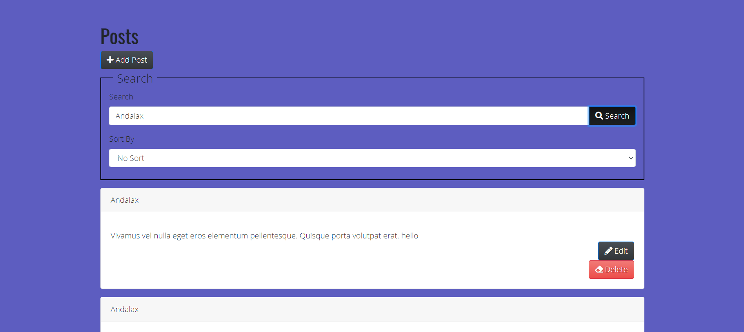

**Purpose and Background**

What will this feature allow users to do? To search, edit, add, and delete posts.

Why do they need this functionality? To easily view and change posts made by other users.

Why is this feature important to the project? Posts are just as valuable to the site as groups and users.

**Workflow**

How will the user interact with the UI? Enter the name of a post to find it.

What is the user workflow?

Provide step by step instructions.

**Possible Errors & Edge Cases**

What are the possible edge cases?

What could cause an error/exception? Invalid information inputted to a field should cause an error.

Consider errors that may arise from user error, software glitches, hardware glitches, and networking problems.

**Error Handling**

How will the user be notified of errors/exceptions? There should be text that pops up under the button.

How will the software handle the errors? Send ajax and json to handlebars